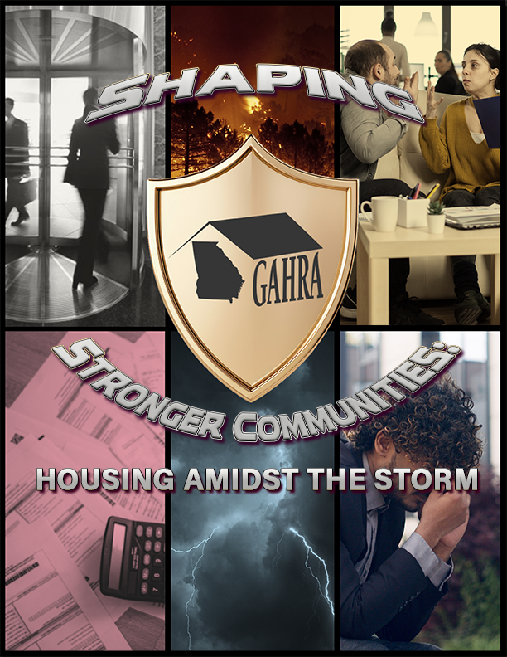

2025 GAHRA ANNUAL CONFERENCE
SEPTMBER 14 – 16, 2025
SAVANNAH RIVERFRONT MARRIOTT
YOU NEED TO BE IN THESE SESSIONS TO GET INFORMED

FINANCIAL MANAGEMENT
There will be 6 mini sessions for all your finance needs presented by Chad Porter, CPA. They are as follows:
- Finance 101 – Understanding the numbers behind Housing Authority operations
- Budget & Procurement – Building a strong financial foundation
- Demystifying those FDS reports
- Audit update – What’s new this year
- Move To Work and how to account for it
- Non-Profit organization – How to create and Why
PROFESSIONAL DEVELOPMENT

Are you interested in a little free money by way of rebates? Who isn’t. Come hear from our friends from Georgia's Home Energy Rebate team who are managing the program. They will be talking about water heater replacement, HVAC replacement, replacement of ranges, and electrical upgrades. It’s a win-win deal being offered with up to $16,000 per unit rebates. Got to be here to get in on this deal.
We’ve had a lot of questions asked on these topics. Come join with Sarah Lamar, Attorney at Law to hear about Employment best practices. You will hear about the importance of documentation and consistency to avoid any discrimination cases. Also, you will hear about employment issues related to ADA/FMLA/PWFA and workers compensation and how to navigate these challenging laws within the workplace. Lastly, you will hear about fair housing and ADA requirements that include addressing requests for service dogs and emotional support animals.
MANAGEMENT

Michael Gifford from the Housing Agency Procurement Assistance from Las Vegas will be presenting several topics to assist you with all you need to know about procurement.

- "40 Things You May Not Know About Housing Agency Procurement (But Really Need To)"
- "Quotes and Bids and Proposals, Oh My! (Important Similarities and Differences)"
- "Independent Cost Estimates (ICE) - Cost Price Analysis (CPA): Why we do them and how they benefit us.”
- "How to formulate a Construction Bid (Effective and Efficient techniques you might not know)"
- "HUD-compliant Best Value Services Procurements: Focus on an Annual Audit Services RFP"

Elizabeth Brackett with Brackett HR from Matthews, NC will be coming to provide training titled “Respectful Workplace: Managing Conflict with Confidence. This session is an interactive management training session designed to help leaders navigate workplace challenges while minimizing risk. Managers will learn how to handle difficult conversations with dignity and professionalism—choosing the right time and place, preparing effectively, and focusing on specific behaviors rather than emotions. The session also covers offering constructive feedback, active listening, and exploring solutions collaboratively. Special attention is given to the legal risks surrounding employee interactions, helping managers prevent claims related to harassment, discrimination, or retaliation while fostering a respectful, compliant workplace.
RAD / MULTIFAMILY

We have a host of presenters coming to join us from the National Housing Compliance group, Bremerton (WA) Housing Authority, Navigate Affordable Housing Partners and the Tampa (FL) Housing Authority. These presenters will be discussing how to collaborate with Contract Administrators and understanding the requirements for Project Based Section 8 and RAD PBRA. In this session you will learn the role of a Contract Administer in the oversight of these programs.

Also, we will be joined by Ron Drennan, Ph.D., a professor at Lanier Technical Collage who will present “Boarders at the Front Door: Housing, Immigration and the Fallout of Project 2025”. Discussion will be held on the sweeping proposals under Project 2025—particularly the push to ban noncitizens from all federally assisted housing—pose immediate and complex challenges for housing providers. This session breaks down what’s real, what’s coming, and what housing professionals need to do right now. We’ll cover naturalization basics, how residents may qualify (and afford) the process, and the immigration statuses you’ll need to understand fast. We’ll also talk strategy: how to protect your agency, ease your team's burden, and support residents—all while staying compliant. Come ready to ask questions, get answers, and walk away with practical tools for navigating this politically charged moment.

INFORMATION AND TECHNOLOGY (IT)

In this session, we will be joined by Dr. Heath Landrum with the “Unconfusing Technology, LLC” in Auburn, Alabama. The Monday morning session is tagged: What is AI and what is it not? This will be a brief introduction of AI, Machine learning, etc. The session will use cases in Public Housing / Scenarios:

- Predictive Analysis for Maintenance / Safety
- Resource Allocation
- Resident Services
- Risks, Ethics, Privacy Concerns, case studies and real-world examples.

In the afternoon, you will have the opportunity to participate in a round table discussion on the Introduction and Framing: Why AI in Public Housing? Examples and Discussion topics will be:
- AI for Tenant Engagement and Communications
- Predictive Maintenance and Inspections
- Case Management and Workflow
- Forecasting and Planning.

HUMAN SERVICES – RESIDENT SUPORT AND FSS

Come participate in this session with Montina Young Frasier, founder of the CIA Media Group LLC from McDonough, GA. This session is entitled “Pathways to Self Sufficiency: Building Confidence, Clarity, Community & R.E.S.P.E.C.T”. The presentation will be delivered in segments and is designed to educate, engage, and empower adult public housing residents. The session will include the following components: - Icebreaker activity to build connection - Interactive workshop format with audience engagement - Take-home handout for practical next steps - Focused action plan residents can implement immediately. The focus will align with GAHRA’s session suggestions and touch on key areas including:

- Defining and pursuing self-sufficiency
- Navigating career and entrepreneurship pathways
- Managing stress and uncertainty
- Understanding and preparing for the “benefits cliff”.

Come and recognize the importance of R.E.S.P.E.C.T.

MAINTENANCE

GAHRA’s Maintenance committee will be joined by Lenny Jackson with BIO=ONE in Augusta, GA to discuss a much troubling issue in maintenance. This interactive training session will provide maintenance staff and property managers with essential knowledge and practical strategies for identifying, preventing, and addressing mold and mildew in residential properties. Participants will learn about the causes and health impacts of mold, effective moisture control techniques, proper cleaning and remediation procedures, and HUD/USDA compliance guidelines.

On Tuesday, the Maintenance Committee will hold a maintenance round table that will be an interactive and collaborative class designed specifically for maintenance professionals in the housing industry. This session provides a unique opportunity for maintenance staff, supervisors, and property managers to come together, share best practices, discuss common challenges, and explore innovative solutions to improve property maintenance and resident satisfaction.

ASSISTED HOUSING

Felicia Meadow with the Atlanta Housing Authority will be providing an engaging and informative session for all in the housing network. She will dive deep into the vital work of their Investigations Department. Discover their innovative strategies for fraud investigation and prevention that can greatly enhance your Housing Authority's efforts. Come and participate in this interactive discussion to gain valuable insights and practical applications of these techniques. Additionally, we will explore the evolution and significance of the Violence Against Women Act (VAWA) and its profound impact on Housing Authorities, making this a must-attend event for anyone committed to effective housing solutions.

COMMISSIONERS

GAHRA Commissioners will be hearing from a most respected Attorney in our housing arena. Stewart Duggan will be joining us for a full day to talk about various subjects that Commissioners need to know. They also can certainly ask questions about anything related to Commissioners. The main topic Duggan will speak on is navigating a Commissioner’s role in avoiding liability and annual review of judicial decisions impacting affordable housing. This session will provide a Commissioner with some great board training, being informed on potential pitfalls as well as legal updates on current issues and hot topics in our business.

HOUING AND REDEVELOPMENT

The Housing and Redevelopment committee has connected with Jermaine Durham, Ph.D., who is the Director of the Georgia Initiative of Community Housing (GICH) who explore the transformative impact of collaborative partnerships between local housing authorities and the Georgia Initiative for Community Housing (GICH). You will gain insights into how strategic outreach, shared resources, and aligned goals can strengthen affordable housing efforts across the state. The session will highlight successful case studies, outline the benefits of cross-sector engagement, and provide actionable strategies for housing authorities to deepen their involvement with GIHC. One will leave with a clearer understanding of how these partnerships can drive sustainable community development and improve housing outcomes for Georgia residents.

